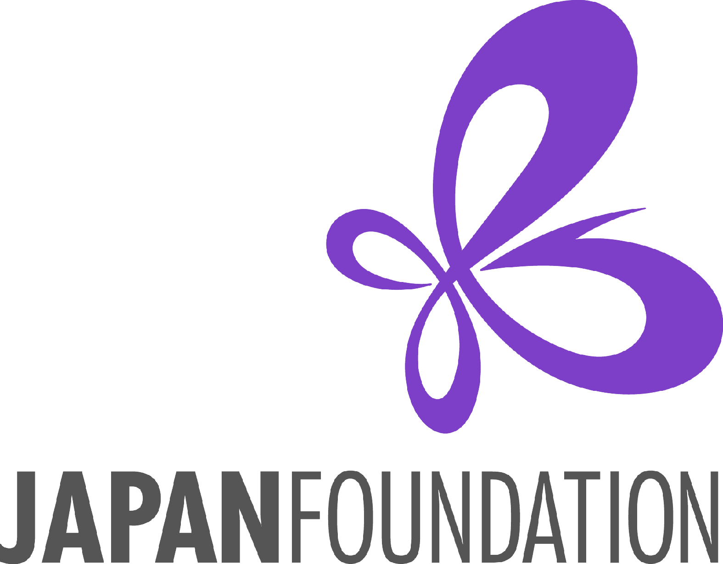Handling of Personal Information

* 1. Handling of Personal Information

1. Compliance with applicable laws

To the extent applicable, the Japan Foundation will comply with the “Act on the Protection of Personal Information” (Act No. 57 of 2003) (the “**Act**”), relevant cabinet and ministerial orders, various guidelines stipulated by the Personal Information Protection Commission or other organizations to which the Personal Information Protection Commission has delegated authority, the “EU General Data Protection Regulation (the “**GDPR**”),” the Personal Information Protection Law of the People’s Republic of China and related laws and regulations (the “**Chinese Laws**”), and other laws and regulations in relation to protection of personal information in relevant countries and regions, etc., and when handling any personal information, the Japan Foundation will properly collect, use and control the same. For more information on the Japan Foundation’s efforts to protect personal information (privacy policy), please visit the following websites:

(Related to the Act): (Japanese) <https://www.jpf.go.jp/j/privacy/>

(English) <https://www.jpf.go.jp/e/privacy/>

(Related to the GDPR): <https://www.jpf.go.jp/e/privacy/index.html#gdrp>

(Related to the Chinese Laws): <https://www.jpfbj.cn/jp/personal_information/>

(2) Acquisition of personal information

The Japan Foundation may acquire the following personal information (the “**Personal Information**”) from the awardees through the application forms, attachments, project reports, deliverables, etc. (the “**Project Materials**”). In addition, the Japan Foundation may acquire the awardees’ Personal Information through publicly available websites.

[Basic information of awardees]

Name, date of birth, nationality, permanent residence, gender, place of employment, job and work duties, home address, postal code, telephone number (including mobile phone number), fax number, e-mail address, ID number, passport number, photographs taken during or prior to the program, etc.

[Information on awardees’ educational background, career history and abilities]

Resume (including educational background and career history), major achievements, foreign language proficiency, overseas residence history, overseas residence plan, contact information during the residence period, etc.

[Sensitive data on awardees]

Personal data such as health-related information and bank account information

(3) Purposes of use and period of personal information

* + - 1. Based on the consent of the awardee the Japan Foundation will use the Personal Information acquired from the awardee for implementation of the project, post-evaluation, communication to awardees and for any and all other purposes for management of awardees (the “**Purposes of Use**”).
      2. For the proper and smooth operation of the Japan Foundation projects, any information such as the awardees’ names, genders, jobs, titles, affiliations, etc. will be: posted on published materials, such as the Detailed Annual Reports of the Japan Foundation (*Kokusai Koryu Kikin Jigyo Jisseki*), the Annual Report and the Japan Foundation’s website; used for preparation of statistics materials; and used for formulation of future Japan Foundation projects.
      3. In addition to the information specified in b. above, the awardees’ contact information (i.e., address, e-mail address and phone number) will be used to: request the awardees to answer questionnaires as follow-up to the project after completion thereof; provide a notice regarding other Japan Foundation projects; request the awardees to provide information for formulation of future Japan Foundation projects, and so on.
      4. The Japan Foundation will handle the Personal Information of the awardees for the period necessary to achieve the Purposes of Use stated above.

(4) Provision of personal information

* + - 1. The Japan Foundation may provide the Personal Information acquired from the awardees to the following organizations, to the minimum extent necessary. The Japan Foundation will make sure that the recipients take measures to ensure the security of the Personal Information.
         1. The Ministry of Foreign Affairs of Japan, Embassies or Consulates-General of Japan, etc. (for handling of security control, support for project implementation, etc.)
         2. Airlines the agencies thereof, etc.
         3. News media and other organizations (for public relations for the projects)
         4. Other organizations and individuals who receive the information as needed for the projects
      2. The awardee’s health information may be provided to medical institutions, medical professionals, organizations or individuals who provide cooperation for health care and safety control.
      3. The Personal Information acquired from the awardees may be used or provided for purposes other than those specified in the Purposes of Use, in accordance with Article 69, Paragraph 2 of the Act, such as providing such Personal Information for administrative organs, other incorporated administrative agencies, local public entities or local incorporated administrative agencies (the “**Administrative Organs**”) as long as the Administrative Organs use the same within the scope necessary to conduct the affairs or services prescribed by applicable laws and regulations and where there is a reasonable ground for such use.

1. Cross-border transfer of personal information
   * + 1. The Japan Foundation may handle the Personal Information acquired from the awardees by transferring the same to the base located in Japan (including the Japan Foundation headquarters) or other countries or regions for the Purposes of Use specified above. The Japan Foundation shall appropriately control the Personal Information in such countries or regions.
       2. In addition to the case specified in the preceding paragraph, the Japan Foundation may provide the Personal Information acquired from the awardees to necessary organizations or individuals in Japan or other countries or regions for the Purposes of Use specified above as needed for the projects, only when the conditions stipulated in laws and regulations are satisfied.

(6) Security control of personal information

The Japan Foundation shall endeavor to prevent unauthorized access and leakage of the Personal Information of the awardees by way of taking appropriate security control measures and control means.

1. Rights pertaining to personal information of awardee

The awardee has the right to access his/her Personal Information, correct inaccurate Personal Information, suspend the use of the Personal Information, etc., to the extent that the Act, the GDPR, the Chinese Laws and other laws pertaining to protection of the Personal Information in the relevant country or region apply.

1. Filing of objections against handling of personal information

In the case where the awardee is dissatisfied with the handling of the Personal Information in the Japan Foundation, such awardee may state his/her objections to the Japan Foundation to the extent permitted by the applicable laws and regulations. In accordance with the applicable laws and regulations, the awardee may also file objections to the authority that has jurisdiction over protection of the Personal Information in the country to which the awardee belongs.

1. Personal information of persons involved in the project

The Personal Information of persons involved in the project other than the awardee, which is submitted by the awardee to the Japan Foundation, shall also be handled in the same manner as stipulated in (1) to (8) above, and therefore, the awardees should provide explanations in advance to the persons involved in the project and obtain their consent.

1. Contact information

Please use the contact details specified in “Instructions” for any opinions, questions, etc. regarding any matters specified in this “Handling of Personal Information” section.

1. Revocation of consent

The awardee has the right to revoke his/her consent to any matters specified in this “Handling of Personal Information” section at any time. The revocation of consent does not affect the legality of the handling of the Personal Information prior to the revocation. In addition, when the awardee does not provide his/her consent or revokes his/her consent, such awardee may not be able to receive necessary information and/or services from the Japan Foundation.